Creating a Public Amazon S3 Bucket on AWS
Step-by-step guide with screenshots, summary and best practices

1. Summary
This document records the process of creating a public Amazon S3 (Simple Storage Service) bucket named "sakshi-pub" in the Europe (Stockholm) eu-north-1 region and uploading a file to it. A bucket is a container for objects (files) in S3. To make it publicly accessible, "Block all public access" was disabled during creation and the public-access warning was acknowledged.
Item | Value
Bucket name | sakshi-pub
Bucket type | General purpose
Namespace | Global namespace
AWS Region | Europe (Stockholm) eu-north-1
Object Ownership | ACLs disabled (Bucket owner enforced)
Block Public Access | Turned off (public access acknowledged)
Versioning | Disabled
Uploaded object | Microsoft.Services.Store.winmd (5.0 KB, Standard class)
Object URL | https://sakshi-pub.s3.eu-north-1.amazonaws.com/Microsoft.Services.Store.winmd

2. Step-by-Step Procedure

Step 1: Open the S3 Console
Sign in to the AWS Management Console, select the region (here Europe – Stockholm, eu-north-1) and open Amazon S3 from the search bar. The "General purpose buckets" page shows 0 buckets, so click "Create bucket".
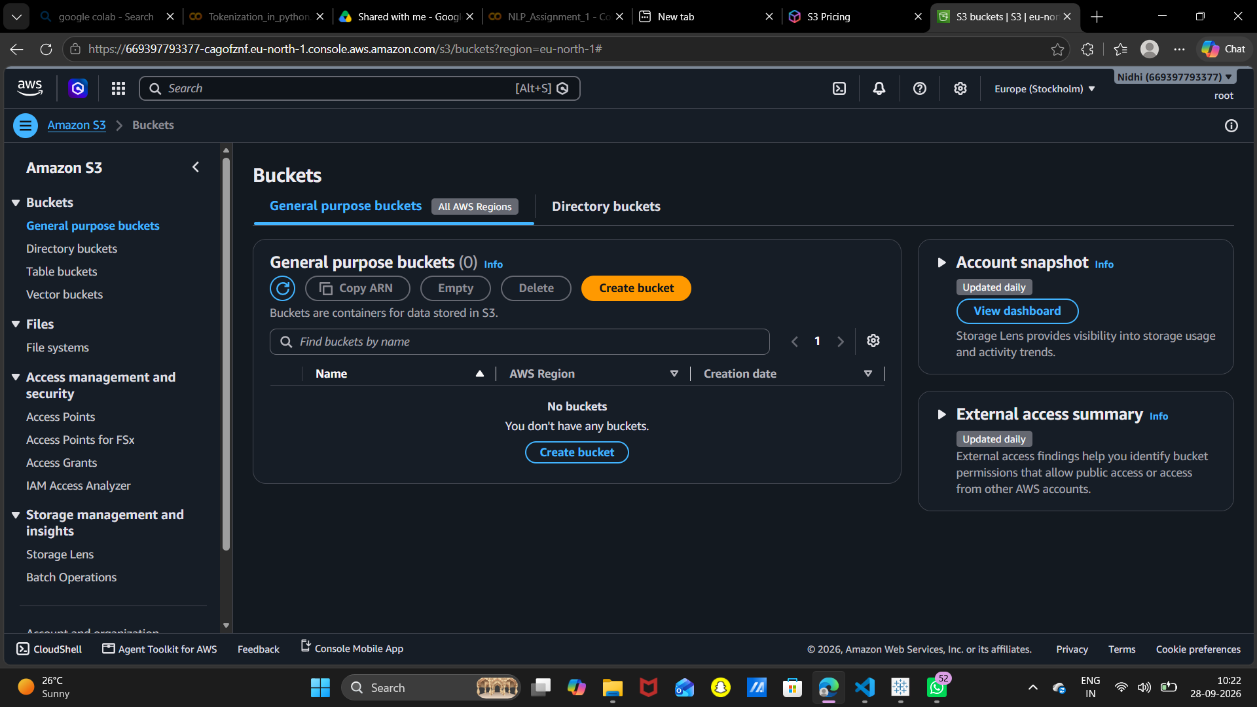
Screenshot 1 – S3 Buckets page (no buckets yet)

Step 2: General Configuration & Bucket Name
Bucket type: General purpose. Namespace: Global namespace. Enter a bucket name. Names must be 3–63 characters, lowercase letters, numbers, periods and hyphens, start/end with a letter or number, and be globally unique. (A draft name "sakshi-08" is visible here; the final bucket was created as "sakshi-pub".)
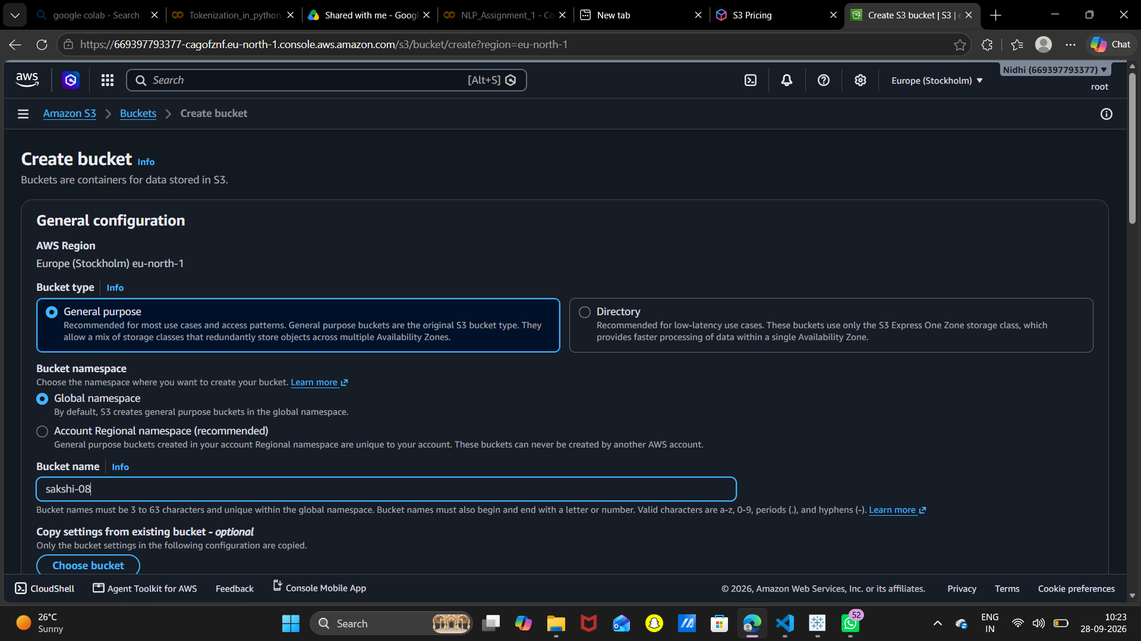
Screenshot 2 – Create bucket: General configuration

Step 3: Object Ownership & Block Public Access
Object Ownership: keep "ACLs disabled (recommended)" – the bucket owner owns all objects. Under "Block Public Access settings" the "Block all public access" checkbox is UNCHECKED (along with its four sub-options). This is the key step that allows the bucket to be made public.
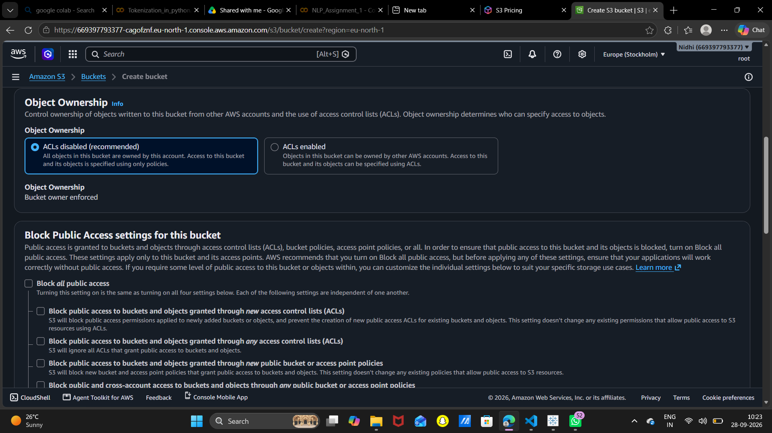
Screenshot 3 – Object Ownership and Block Public Access settings

Step 4: Acknowledge the Warning, Versioning & Tags
Once Block Public Access is turned off, AWS shows a warning. You must tick "I acknowledge that the current settings might result in this bucket and the objects within becoming public." Bucket Versioning is left as Disable, and Tags are optional (none added). Default encryption is left at its default and then click "Create bucket" at the bottom of the page.
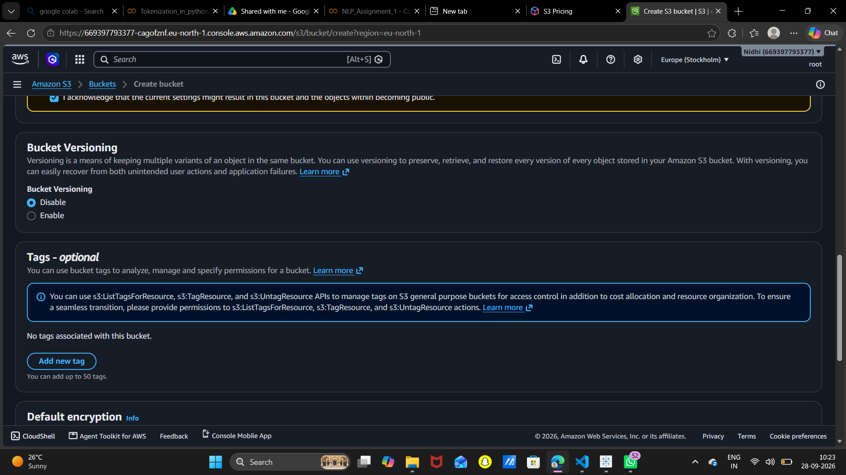
Screenshot 4 – Public access acknowledgement, Versioning and Tags

Step 5: Bucket Created Successfully
A green banner confirms: Successfully created bucket "sakshi-pub". The bucket page opens on the Objects tab, which is empty (Objects (0)). Click "Upload".
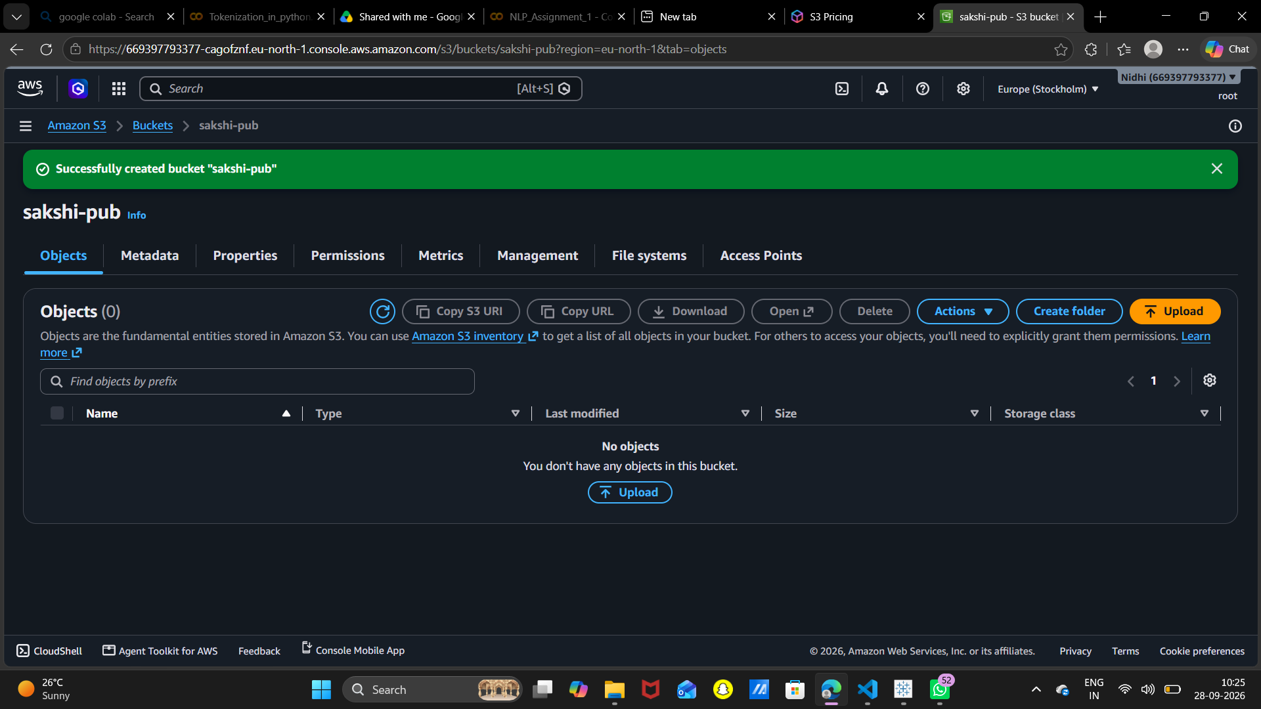
Screenshot 5 – Bucket "sakshi-pub" created

Step 6: Open the Upload Page
The Upload page shows the destination s3://sakshi-pub. Use "Add files" or "Add folder" (or drag and drop) to select what you want to upload.
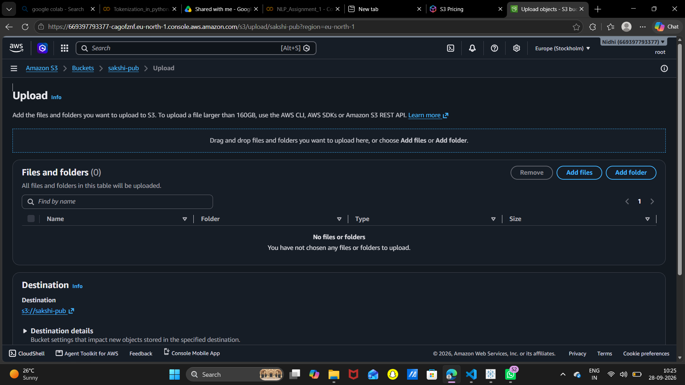
Screenshot 6 – Upload page (no files selected)

Step 7: Add a File and Upload
One file (Microsoft.Services.Store.winmd, 5.0 KB) has been added. The optional Permissions and Properties sections can be expanded to set public access, storage class, encryption and tags. Click "Upload".
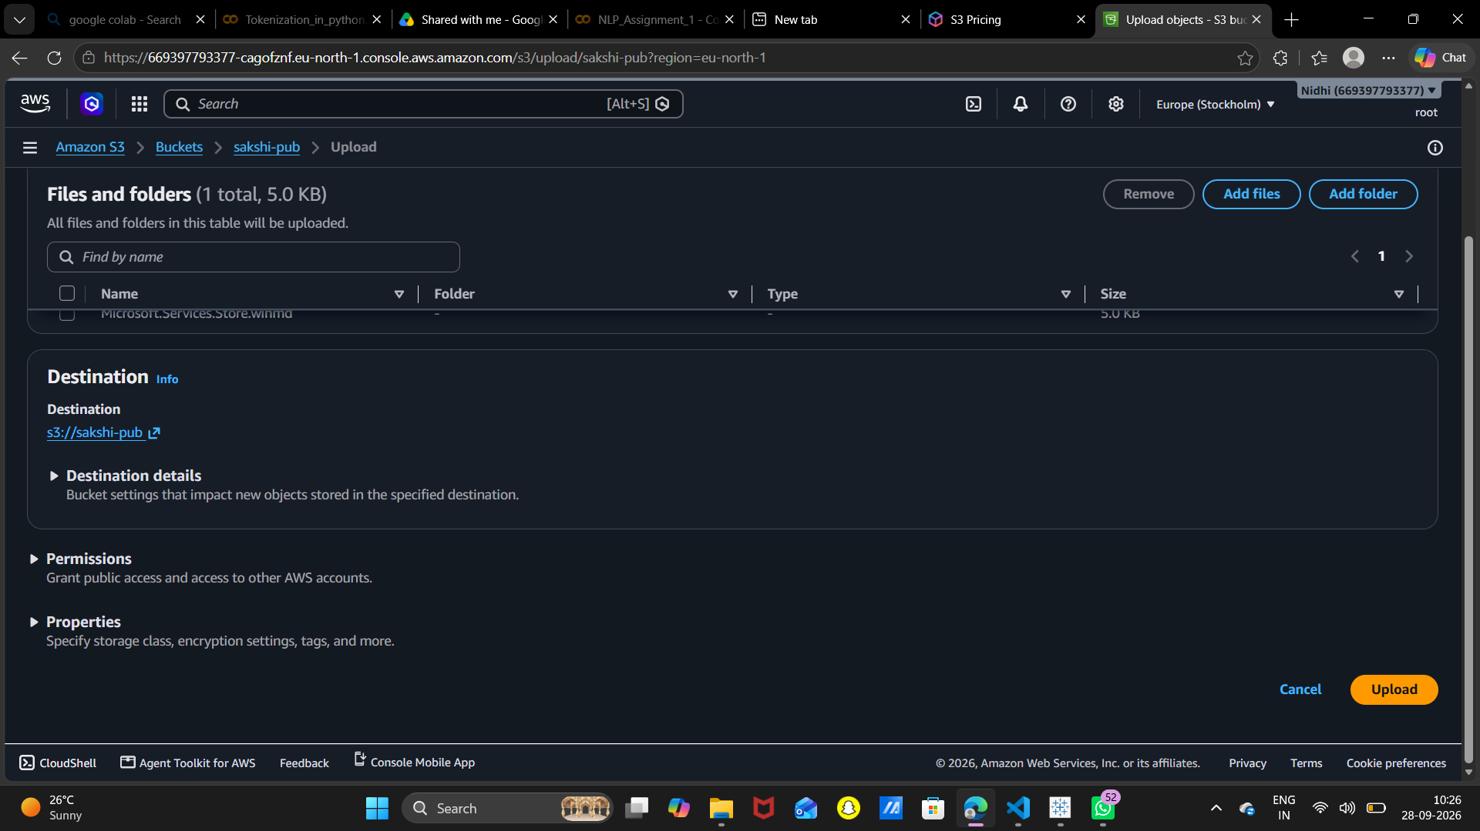
Screenshot 7 – File added, ready to upload

Step 8: Verify the Upload
The bucket Objects tab now shows Objects (1): the file, type winmd, size 5.0 KB, storage class Standard, last modified September 28, 2026, 10:26:08 (UTC+05:30).
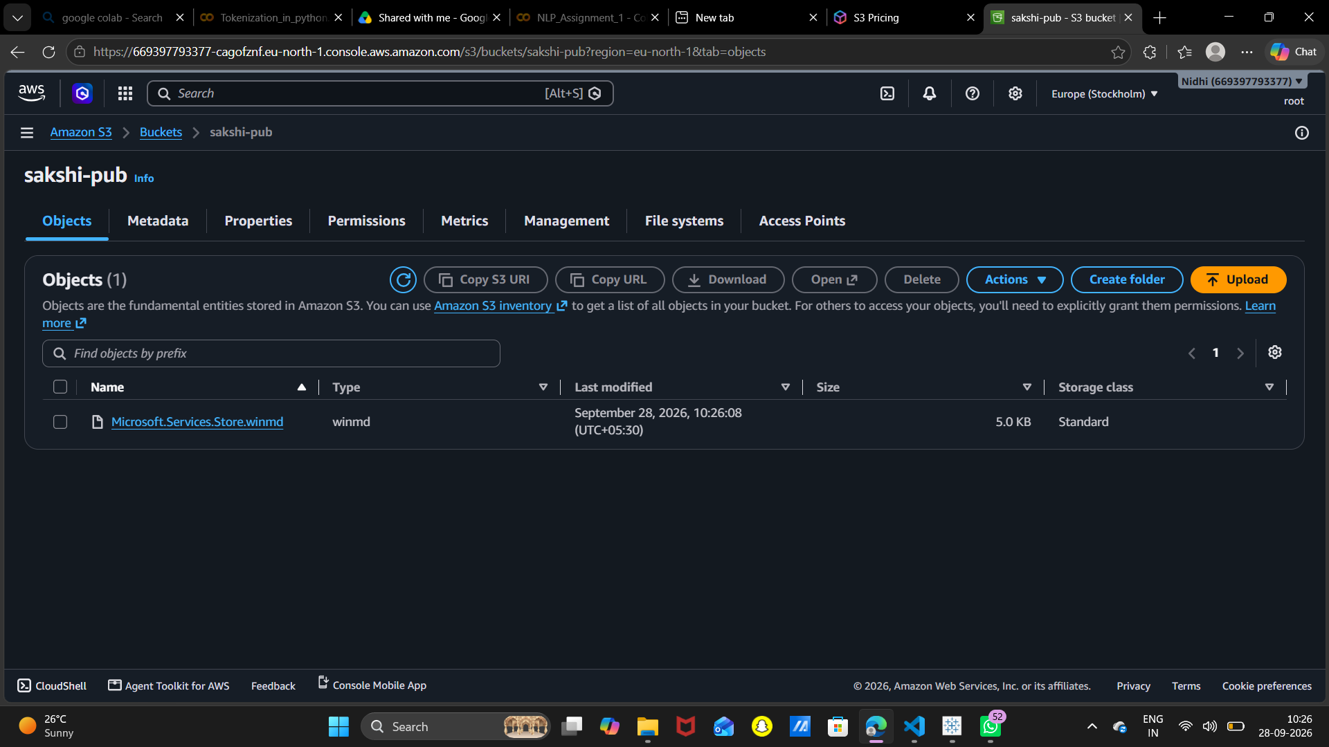
Screenshot 8 – Uploaded object listed in the bucket

Step 9: Check Object Details & Object URL
Clicking the object opens its Properties: owner, AWS Region, size, key, S3 URI (s3://sakshi-pub/Microsoft.Services.Store.winmd), ARN, ETag and the Object URL (https://sakshi-pub.s3.eu-north-1.amazonaws.com/Microsoft.Services.Store.winmd).
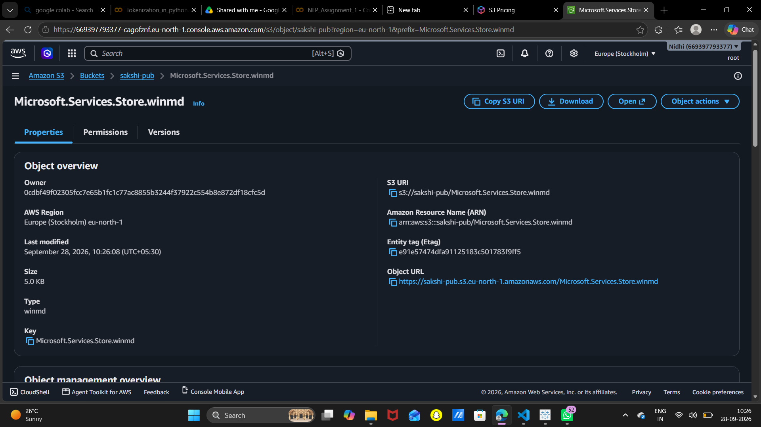
Screenshot 9 – Object overview with S3 URI and Object URL

3. Additional Notes (Important)

3.1 Unchecking "Block public access" is not enough by itself
Turning off Block Public Access only removes the safety lock. Objects are still private until you grant read access. In the screenshots, ACLs are disabled, so the correct way is a Bucket Policy. Go to the bucket > Permissions > Bucket policy > Edit, and paste the policy below (replace the bucket name if different):
{
"Version": "2012-10-17",
"Statement": [{
"Sid": "PublicReadGetObject",
"Effect": "Allow",
"Principal": "*",
"Action": "s3:GetObject",
"Resource": "arn:aws:s3:::sakshi-pub/*"
}]
}

After saving, the Object URL should open in a browser. If it shows "Access Denied", check that Block Public Access is off at both the bucket level and the account level (S3 > Block Public Access settings for this account).

3.2 How to test public access
- Open the Object URL in an incognito/private browser window (not logged in to AWS).
- If the file downloads or displays, the bucket is public. If you see an "AccessDenied" XML message, the policy is missing or public access is still blocked.

3.3 Security best practices
- Only make a bucket public when needed, for example static website hosting or public images/documents.
- Never upload sensitive data (personal files, passwords, keys, system files) to a public bucket. The uploaded .winmd file is a Windows system file and should be replaced with your actual project files.
- Limit the policy to s3:GetObject (read only). Never allow s3:PutObject or s3:DeleteObject to Principal "*".
- Avoid using the root user for daily work. The screenshots show the account is signed in as "root"; create an IAM user with MFA instead.
- Protect account details when sharing screenshots: the AWS account ID appears in the URL and the top-right corner.

3.4 Cost awareness
- You pay for storage used (per GB per month), requests (GET/PUT) and data transfer out to the internet. A public bucket can incur unexpected data-transfer charges if many people download files.
- The AWS Free Tier includes limited free S3 storage and requests for new accounts (check the S3 Pricing page for current values).

3.5 Useful AWS CLI commands (optional)
aws s3 mb s3://sakshi-pub --region eu-north-1
aws s3 cp myfile.txt s3://sakshi-pub/
aws s3 ls s3://sakshi-pub
aws s3 rm s3://sakshi-pub/myfile.txt
aws s3 rb s3://sakshi-pub --force

3.6 Common problems and fixes
Problem | Likely cause / fix
Bucket name already exists | Bucket names are global. Add a unique suffix, e.g. sakshi-pub-2026.
Access Denied on Object URL | No bucket policy, or Block Public Access still on (bucket or account level).
Cannot edit bucket policy | Block Public Access "new/any public bucket policies" options are checked. Uncheck them.
Unexpected charges | Delete objects and the bucket when finished; set a billing alarm in AWS Budgets.

3.7 Cleaning up
To avoid charges, first empty the bucket (select the bucket > Empty), then delete it (Delete). A bucket must be empty before it can be deleted.

4. Conclusion
A public S3 bucket was created in 9 simple steps: open S3, create the bucket, disable Block Public Access, acknowledge the warning, create the bucket, upload a file and verify the object. To actually serve files to everyone, add a read-only bucket policy and test the Object URL in an incognito window. Always follow the security and cost practices above.

